LAKE SHERWOOD
ESTATES
RULES AND REGULATIONS
VOLUME III

January 2005
Revised March 1, 2019

TABLE OF CONTENTS
LAKES, DAMS, MARINAS, WATERCRAFT, SWIMMING, WATERSPORTS, FISHING

Article 1 Authorization
Article 2 Definitions
Article 3 WATERCRAFT and Boat Trailer Registration
Article 4 Inboard/Outboard/Inboard-Outboard Restrictions
Article 5 WATERCRAFT and Boat Trailer Parking
Article 6 Enforcement
Article 7 Boating Operations on Lake Sherwood (main lake)
Article 8 Lake Swimming
Article 9 Control of Aquatic Vegetation
Article 10 Irrigation Using Lake Water
Article 11 Boat Dock Inspections
Article 12 Fishing Regulations
Article 13 Parks on Lake Sherwood
Article 14 Penalties for Violation Published Boating/Lake Rules
Appendices
A --- WATERCRAFT/Trailer Registration Application
B --- Measuring LENGTH of WATERCRAFT
C --- Lake Map
D --- Lake Sherwood Registration Decal Placement
E --- Marina Slip Diagram

ARTICLE 1
AUTHORIZATION
The following rules are adopted under the authority contained within Section 26 of the Lake Sherwood Estates Association (LSEA) Declaration of Restrictions. Such authority is to help foster the safety of users of our lakes and to promote conservation and quality of the LSEA’s water resources. LSEA undertakes no obligation as to the safety and security with respect to the use of our lakes and parks and no representations are made to that effect. Users of our lakes assume the risk of such utilization of our lakes, and parks associated with the lakes.
The Lake Sherwood Estates Association Water Patrol has the right to stop and inspect your WATERCRAFT before it goes onto any lake or while it is on any lake for compliance with LSEA boating rules and regulations. Refusing to comply may result in the termination of the applicant’s right to use the lakes, without reimbursement, until the WATERCRAFT complies.
The Lake Sherwood Estates Association Water Patrol also has the right to stop and ticket your WATERCRAFT for lake rule violations as outlined in this volume.
Anyone swimming in any of Lake Sherwood’s lakes does so at their own risk.
ARTICLE 2
DEFINITIONS
The following definitions are in addition to any definitions in the Declaration of Restrictions and By-Laws. Capitalized words in these Rules refer to defined terms in the Declaration of Restrictions and the following additional definitions.
- BOW - The forward or front part of a WATERCRAFT.
- GRANDFATHERED - Refers to WATERCRAFT that no longer meet current restrictions but were permitted and registered under previous restrictions and are continued to be permitted within Lake Sherwood as long as the association MEMBER remains in good standing and maintains current registration of WATERCRAFT.
- IDLE SPEED/NO WAKE - The SLOWEST SPEED at which a watercraft will move through the water. WATERCRAFT operating at IDLE SPEED/NO WAKE create very little boat wake.
- INFLATABLE SWIM PLATFORMS - An inflatable platform (party lounge, aqua jump trampoline, etc.) larger than 8 feet by 8 feet but smaller than 12 feet by 12 feet and 4 feet in height.
- LENGTH - The overall LENGTH of the WATERCRAFT when measured from the BOW through the mid-line of the WATERCRAFT to the STERN, excluding removable protuberances and propulsion devices.
- NON-FUEL WATERCRAFT - A vessel that is powered by a source other than fuel. Examples include canoes, rowboats, kayaks, sailboats, inflatables, paddle boats. NON-FUEL WATERCRAFT may be powered by electric trolling motors.
- MEMBER - defined under Article 20 of the LSEA Declaration of Restrictions.
- MP-1 - The WATERCRAFT/trailer reserved parking area located adjacent to the marina.
- MP-2 - The WATERCRAFT/trailer reserved parking area below the Lake Sherwood Dam.
- RENTER - The MEMBER as defined under Article 20 of the LSEA Declaration of Restrictions, designated RENTER. Such RENTER may be assigned MEMBER privileges only if the MEMBER as defined in Article 20 of the restrictions surrenders such privileges to the RENTER as they are associated with the rules here within Volume III.
- OPERATE - To navigate or otherwise use a WATERCRAFT
- OPERATOR- The person who OPERATES or has charge of navigation or use of WATERCRAFT.
- OWNER- The person other than the lien holder having the property in or title to the WATERCRAFT.
- PERSONAL WATERCRAFT (PWC) – A vessel which is less than sixteen feet in LENGTH, fuel or battery powered, propelled by mechanical means, and is designed to be OPERATED by a person holding onto, sitting, standing or kneeling “on” the vessel rather than being OPERATED by a person sitting or standing “inside” the vessel.
- PONTOON BOAT- A WATERCRAFT constructed with detachable pontoon flotation (i.e., steel, aluminum, or fiberglass) and with a hull tunnel that does not touch the water’s surface when at maximum weight load.
- PORT- The left side of a WATERCRAFT as you are facing forward.
- POWERBOAT - A fuel powered WATERCRAFT that may also be referred to as an outboard, inboard or inboard/outboard.
- SKI BUOYS - Conical blue and white buoys that mark the perimeter or boundary of the ski lane on Lake Sherwood.
- STARBOARD - The right side of a WATERCRAFT as you are facing forward.
- STERN - The aft end or back of a WATERCRAFT.
- TOWING - The use of “towing” or “towers,” in this document, includes skiers, tubers, wake boarders etc.
- UTILITY TRAILER - A non-motorized vehicle which is generally pulled by a motorized vehicle, is 16 feet or less in LENGTH and features an enclosed or open-top rear cargo area (bed) and is used for the hauling of light loads
- WAKE - Waves or path that a boat leaves behind as it moves across the water. ”Slow No Wake Area”, “Idle Speed Area”, and “No Wake Area” are all the same. These are areas in which ALL WATERCRAFT MUST OPERATE AT IDLE SPEED/NO WAKE SPEED.
- WATERCRAFT - Any boat or craft, including a vessel used or capable of being used as a means of transportation on water.
ARTICLE 3
WATERCRAFT AND BOAT TRAILER REGISTRATION
- WATERCRAFT may only be registered by LSEA MEMBERS/associate MEMBERS in good standing or RENTERS to whom MEMBER privileges have been surrendered to them by their landlord.
- All WATERCRAFT must be registered with Lake Sherwood Security. All POWERBOATS must comply with U.S. Coast Guard Regulations.
- Registration of POWERBOATS for the very first time, requires the MEMBER OWNER of such POWERBOAT to present the original registration &/or title for the motor, trailer and the WATERCRAFT. Such registration must be in the name of the MEMBER. No copies of registrations or copies of titles will be accepted when POWERBOATS are registered inside Lake Sherwood for the very first time.
- Registration requires a certificate of insurance, in the MEMBER’S name, evidencing current liability coverage. Copies of such certificates are allowable.
- POWERBOATS registered for the very first time with Lake Sherwood Security will have the manufacturer’s identification numbers on the boat and motor registrations or titles with the same number on the actual POWERBOAT and motor.
- All NON-FUEL WATERCRAFT such as canoes, kayaks, paddleboats, paddleboards, inflatable boats, sailboats without fuel powered engines and catamarans must be registered with Lake Sherwood Security.
- Registration for any WATERCRAFT is limited to the hours of 7:00 AM to 9:00 PM, Monday through Friday.
- Current annual colored registration decals can only be purchased by MEMBERS in good standing.
- Annual colored registration decals must be properly affixed to WATERCRAFT and trailers on or prior to March 31st of each year.
- Failure to display your registration decal while navigating will result in Lake Security informing you that you must immediately remove your WATERCRAFT from the water. Security will record this breach of the rules.
- To return to the water you will be required to purchase current annual colored registration decals. A $25.00 fine will be assessed and escalate for repeat violations.
- Failure to abide by the registration decal rules a third time will result in loss of all boating privileges for the current year. You will be instructed to remove your WATERCRAFT from the lake. If not voluntarily removed you will be considered trespassing and LSEA will have the WATERCRAFT removed. All costs will be your responsibility. A fine will be assessed.
- The proper placement of the annual colored registration decals is on both the PORT and STARBOARD sides near the rear of the craft. The registration decals must be visible at all times, even when the boat is covered. Only current year registration decals may be displayed on any WATERCRAFT or trailer.
- MEMBER Landlords may assign all privileges to RENTERS and either RENTER or MEMBER landlord may register WATERCRAFT, but not both. MEMBER landlords are required to notify LSEA of termination of rental contract. Such privileges assigned to the RENTER shall cease upon termination of rental contract.
- All WATERCRAFT trailers parked within and on Lake Sherwood Estates must be properly registered with Lake Sherwood Security and must display the current annual colored registration decal.
- The same rules that apply to WATERCRAFT on the water will be applied to WATERCRAFT trailers.
- Day parking is available for registered trailers at MP-1 and the west end of Lake Sherwood north of the overflow pipes. No camper trailers or motor homes may be parked at MP-1 or MP-2.
- Lake Sherwood WATERCRAFT registration, parking, rack storage, and boat slip privileges are nontransferable.
- The registration of WATERCRAFT or WATERCRAFT trailers expires as follows:
  - March 31st
  - With transfer of WATERCRAFT or trailer title
  - When Association MEMBER’s property is sold
ARTICLE 4
INBOARD/OUTBOARD/INBOARD-OUTBOARD RESTRICTIONS
- Except for PONTOON BOATS, the maximum boat LENGTH for all boats registered for use on Lake Sherwood is twenty feet, zero inches (20’0”) as indicated in the diagram of Appendix B.
- PONTOON BOATS being registered for use on Lake Sherwood are limited to twenty-four feet, zero inches (24’0”) in LENGTH and eight (8) feet six (6) inches in width.
- Maximum WATERCRAFT LENGTH on Marion, Eleanor, Robin Hood and Sugar Hollow is eighteen (18) feet. Maximum width is eight (8) feet, six (6) inches.
- Maximum horsepower for any POWERBOAT on Lake Sherwood is 160 HP for outboards, including jet drive outboards. All other motor types are limited to 3.0 liters. OWNERS must be able to provide proof of horsepower.
- No WATERCRAFT with fuel-powered engines mounted, are permitted on Lake Robin Hood, Lake Sugar Hollow, Lake Marion, Lake Eleanor or Lake Alan. Exception: WATERCRAFT with fuel-powered engines are allowed for LSEA Maintenance and LD&M while performing duties on behalf of LSEA. A $100 fine will be issued for the first violation and escalate for subsequent violations.
- Electric motors may be used on all lakes with no horsepower restrictions.
- Jet skis, jet boats, wet bikes, wave runners, Craig Cats and similar crafts, and other PERSONAL WATERCRAFT (PWC) are prohibited unless GRANDFATHERED prior to April 18, 1989. Sea planes, air boats, hovercraft and submersibles (sea scooters, personal propellers), wake kites, flying tubes and parasails are all prohibited.
- It is the intention of Lake Sherwood to register traditional WATERCRAFT only. If a new type, style, form, shape, design or modification of a normal WATERCRAFT is submitted for registration, the vessel must be reviewed and approved by the Lakes, Dams, and Marina Committee or their designees prior to admittance to Lake Sherwood Estates.
- The number of registered fuel-powered WATERCRAFT is limited to two (2) per lot. Only two (2) fuel-powered WATERCRAFT are permitted per permanent dock.
- As of March 1, 2005, failure to renew the annual registration decal by March 31 for GRANDFATHERED WATERCRAFT negates the grandfathering clause and makes such craft ineligible for future registration. Also, Lake Sherwood Estates reserves the right to declare a sunset clause applicable to GRANDFATHERED WATERCRAFT.

ARTICLE 5
WATERCRAFT AND TRAILER PARKING
- Outdoor parking of power navigable boats and serviceable boat trailers is restricted to MP1 and MP2.
- Outdoor parking of enclosed and “empty” open top serviceable UTILITY TRAILERS is allowed at MP1 and MP2. Priority of parking goes to serviceable boats and boat trailers.
- Outdoor parking of enclosed (box) trailers must be free of any socially unacceptable verbiage or graphics and are subject to approval on a case-by-case basis. Priority goes to serviceable boats and boat trailers. To ensure hazardous/illegal materials are not stored in these trailers, MEMBERS wishing to store an enclosed trailer at MP1 or MP2 must consent to random and unannounced inspections, by LSEA Staff, of the contents of the trailer. MEMBERS must further surrender a key to the trailer which LSEA will maintain in a secure fashion so as to prevent any unauthorized access by LSEA Staff.
- WATERCRAFT trailer storage space is available for lease by MEMBERS in-good-standing. Lessee must store a boat/trailer, registered with LSEA in his/her name. Lessee may not assign or sublet this lease.
- With the paid fee, MEMBERS may store non-power WATERCRAFT on the reserved racks located at Lake Sugar Hallow, Lake Robin Hood, MP1 and MP2.
- No WATERCRAFT, WATERCRAFT trailer or other marine item shall be parked or stored for over a period of five days within a thirty (30) day period on any lot, street or driveway. Exception: Non-motorized WATERCRAFT may be stored within thirty feet of a lakefront property owner’s shoreline provided, the WATERCRAFT displays current registration decals belonging to the property owner, the WATERCRAFT is stored in a orderly manner or rack system that avoids the collection of rainwater. Rack systems need to be approved by the Lakes, Dams, and Marina Committee before installation
- Failure to make payment of the annual rental space fee by March 31 will cause immediate surrender to the rights of the reserved parking location. Lake Sherwood will make a reasonable attempt to notify the MEMBERS that such fees are due however it is the MEMBER’S responsibility to insure that fees are paid on time. Failure to pay fees will result in the removal of the trailer and/or WATERCRAFT at the OWNER’S expense as this will be considered trespassing.
- Any WATERCRAFT left in the water must be moored to a permanent dock. Any WATERCRAFT in the water not moored may be secured or removed from the lake by the LSEA.
- Temporary boat trailer parking at MP1 is only permitted in the Day Parking area at end of the marina and in the two spaces in front of the comfort station.
- MEMBERS who wish to store a WATERCRAFT within Lake Sherwood Estates that does not comply with Article 4 (above) must first submit a request to the Lakes and Dams and Marina Committee for review and approval. The request must contain all the relevant information required in Article 3 (above). The MEMBER must also sign a statement that acknowledges the MEMBER’s understanding and agreement that if the WATERCRAFT should ever be placed on any LSEA lake, the MEMBER’s boating related privileges will be suspended, without reimbursement, for a period of not more than 2 years. The MEMBER must immediately remove all of his/her WATERCRAFT and boat trailers from within LSEA for the remainder of the suspension.
If the request is approved, the MEMBER must complete an MP1 or MP2 parking space rental agreement within 14 days. LSEA Security will register the boat trailer only. The subject boat will not be registered and will not be issued an LSEA boat decal.
10. The Association Manager will, in conjunction with the Lakes, Dams, and Marina Committee, develop and follow a standardized Boat/Trailer Decal and Storage Rental Procedures that establishes the equitable assignment and management of all boat/trailer storage.
11. The following restrictions will be enforced:
- Only one boat and/or trailer may be stored in a single marina slip, parking space, or rack slot. Exception: up to 2 kayaks may be stored in a single rack slot provided the kayaks are stored and secured in such a fashion that they don’t infringe on the neighboring slot.
- Members who own a Lakefront Lot on the main lake (Lake Sherwood) may not rent a marina slip without first obtaining approval of a written appeal submitted to the Lakes, Dams, and Marina Committee.
- Only one Marina Slip may be rented to any MEMBER/Lot regardless of the number of Lots or motorized WATERCRAFT the MEMBER owns. This also applies to Members who co-own a Lot.
ARTICLE 6
ENFORCEMENT
- Water Patrol will begin enforcement of WATERCRAFT and trailer registrations on March 31st.
- The monitoring of both WATERCRAFT and trailers will be an on-going process.
- Refer to Article 3 for further information regarding enforcement.
ARTICLE 7
BOATING OPERATIONS ON LAKE SHERWOOD (MAIN LAKE)
LSEA has adopted the rules and regulations of the Department of Public Safety - Missouri State Water Patrol. These rules are described in “Missouri WATERCRAFT Manual/A Guide to Safety”. Specific LSEA boating rules will take precedence because of our lake size (131 acres). These are as follows:
- All WATERCRAFT must be OPERATED by a qualified and/or licensed OPERATOR as defined by the state of Missouri.
- All WATERCRAFT must navigate Lake Sherwood in a counter-clockwise direction within the blue and white SKI BUOYS in the main channel except during published IDLE SPEED/NO WAKE hours. Boats in tow for recreation must use the entire counter-clockwise ski route around the lake. Boats in tow must never shortcut the ski route. Boats, when not in tow, are allowed to take short cuts from the ski route provided the short cuts are made with caution and perpendicular to the shore.
- The speed limit on lake Sherwood is 30 miles per hour (mph) maximum.
- Inside the SKI BUOYS (shore-side of the blue and white buoys) are IDLE SPEED/NO WAKE zones and all WATERCRAFT OPERATORS must reduce their speed accordingly.
- Boats shall not tow more than one person at a time. All persons being towed must wear a certified life preserver.
- Any boat towing a person requires an observer that is at least 12 years of age.
- Tow lines are to be at least fifty (50) feet long and no longer than 75 feet long.
- POWERBOATS towing or pulling skiers and/or other towing devices must NOT TOW in the area between the shore and the blue and white SKI BUOYS nor tow within any idle speed zone.
- No more than twelve (12) water skiers or other towed devices are permitted on the lake at one time. Additionally, Lake Sherwood Water Patrol has the authority to limit the number of skiers and/or towing WATERCRAFT operating on the lake at any time to insure safety.
- Boats shall maintain a minimum of 150 feet (LENGTH of 2 ski ropes) behind the skier/tuber or no closer than 75 feet (LENGTH of 1 ski rope) from the side of skier/tuber.
- Water bladders or any other device used for the purpose of increasing the weight of any boat are prohibited.
- IDLE SPEED/NO WAKE takes effect on Lake Sherwood when the pool level is twelve (12) inches above or forty-eight (48) inches below normal pool. Notification will be posted at the main gate, the marina and at Spillway Park
- Ski hours and IDLE SPEED/NO WAKE times and dates:
MONTH SKI HOURS NO WAKE /IDLE SPEED
April 1-30 9:00 AM - 7:30 PM 7:30 PM - 7:30 AM
May 1-31 9:00 AM - 7:30 PM 7:30 PM - 7:30 AM
June 1-30 9:00 AM - 8:00 PM 8:00 PM - 7:30 AM
July 1-31 9:00 AM - 8:00 PM 8:00 PM - 7:30 AM
August 1-September 7 9:00 AM - 7:30 PM 7:30 PM - 7:30 AM
September 8-30 9:00 AM - 6:00 PM 6:00 PM - 7:30 AM
October 1-30 9:00 AM - 6:00 PM 6:00 PM - 7:30 AM
November 1- March 30 9:00 AM - 5:00PM 5:00 PM - 7:30 AM
- From April through Labor Day non-powered boats may navigate any part of Lake Sherwood from the start of evening IDLE SPEED/NO WAKE to 7:30 AM the next day. From sunset to sunrise such WATERCRAFT must be equipped with appropriate lighting. From the hours of 7:30 AM until evening IDLE SPEED/NO WAKE said WATERCRAFT must remain between the shore and the blue and white SKI BUOYS except wind driven craft. From April 1 through Labor Day no wind driven craft shall be on the lake on weekends and holidays except during evening no-wake hours to 7:30 AM.
- Anchoring of WATERCRAFT is permitted at any time in the IDLE SPEED/NO WAKE areas. All coves are IDLE SPEED/NO WAKE areas. During posted “Idle Speed Only” hours, boats may anchor anywhere on the lake.
- Tying or anchoring to gabion walls or buoys is prohibited.
- Fuel powered remote controlled / radio controlled model boats are prohibited on all lakes.
- All courtesy docks are for short term parking only; no overnight parking allowed.

ARTICLE 8
LAKE SWIMMING
- Anyone swimming in any of Lake Sherwood’s lakes does so at their own risk.
- Except as noted elsewhere in the restriction’s lake swimming is limited to marked swimming areas and to the area within fifty (50) feet of the shore of private properties.
- All lake swimmers must wear swimsuits or cutoffs.
- Swimming is prohibited at all times in the main channel of the main lake (Lake Sherwood). A $500 fine shall be levied against any person caught swimming (with or without a floatation device) in the main channel, as identified by BUOYS, other than a fallen skier/tuber. Swimming at the island is only permitted on the south side as identified by buoys. MEMBERS are responsible for such a fine should their guest be the violator.
- Swimming is permitted from boats securely anchored in IDLE SPEED/NO WAKE areas in all coves except Marina Cove. Swimmers must remain within 25 feet of the anchored boat the “skier down / person in the water” flag must be prominently displayed.
- Scuba and snorkeling are permitted in Lake Sherwood, only in the IDLE SPEED/NO WAKE zones and coves (except Marina Cove), at all times. This activity is permitted lake-wide during IDLE SPEED/NO WAKE times.
- Divers must display a scuba divers’ marker (red flag /w diagonal white bar) and have a spotter.
- All swimmers and divers must remain within 25 feet of anchored boats.
- Swimming is not permitted from the courtesy docks located at the Community Center, Marina, or main dam.
- Swimming is not permitted anywhere along the main dam or within 100 feet immediately outside the Community Center’s designated swimming area.
- INFLATABLE SWIM PLATFORMS or water toys are allowed in IDLE SPEED/NO WAKE swim areas of Lake Sherwood. The leading edge must not extend more than 6 feet from the end of dock or 25 feet from shore. They must be secured when in use and removed every night. The same rule applies to Lakes Robin Hood, Sugar Hollow, Eleanor, and Marion. No inflatables of any size are allowed on Lake Alan.
ARTICLE 9
CONTROL OF AQUATIC VEGETATION
Control of aquatic vegetation should be accomplished by manual or mechanical removal only. Chemical weed control of lakes by MEMBERS is prohibited without written approval from the Lakes, Dams, and Marin Committee. No aquatic vegetation shall be introduced into any of the lakes unless done so under the written approval and supervision of the Lakes, Dams, and Marina Committee. A $100 fine will be issued for the first violation and escalate for subsequent violations.
ARTICLE 10
PUMPING WATER FROM THE LAKES
Use of lake water for the purpose of irrigating/watering lawns is strictly prohibited. The pumping of lake water for any other purpose requires written approval of the Lakes, Dams, and Marina Committee. A $100 fine will be issued for the first violation and escalate for subsequent violations.
ARTICLE 11
BOAT DOCK INSPECTIONS
Boat docks and shoreline will be inspected annually for deterioration and improper dock maintenance and anchoring. MEMBERS will be notified if their dock and/or shoreline are not within compliance of current ACC/PSC guidelines. MEMBERS will be given an appropriate amount of time to rectify the problem. Any floatation replacement on existing docks will require the use of encapsulated foam billets manufactured specifically for dock floatation.
ARTICLE 12
FISHING REGULATIONS
- Lake Sherwood is governed by the fishing codes as published annually by the Missouri Department of Conservation.
- Lake Sherwood has an aggressive fish habitat program. Fishing structures in lakes are property of Lake Sherwood. The introduction of manmade fish structure requires the written approval and supervision of the Lakes, Dams, and Marina Committee.
SPECIES SEASON DAILY LIMIT SIZE
Crappie all year 15 10” minimum
Channel Cat all year 10 15”minimum
Bass all year 1 over 15”
Bass closed 0 12” to 15”
Bass all year no limit under 12”
Redear all year 10 no limit
Bluegill all year no limit no limit
Bullfrogs closed
Green Sunfish all year keep all, do not return to lake
- Trout: The designated lake stocked with trout IS CLOSED TO ALL FISHING from the date of stocking THROUGH THANKSGIVING DAY. Starting Thanksgiving Day, open season fishing is permitted for trout. The limit for trout is three (3) per day per person.
- All bass under 12 inches and all Green Sunfish should not be returned to the lake.
- Release all bass between 12 and 15 inches back to the lake unharmed immediately after being caught.
- We are requesting all bass over 15 inches be released, except trophy fish.
- Fines for all fishing violations are as follows: $100.00 plus $5.00 per fish in possession for the first offense; doubled for additional violations within a 36-month period. No warnings will be issued as rules are posted on all the lakes and in Rules and Regulations Volume III / “Lakes, Dams, Marinas, WATERCRAFT, Swimming, Watersports, Fishing”.
- The Missouri Conservation Commission may make recommendations and changes which will be posted. LSEA may amend limits in order to protect any fish species.
- Jug fishing, limb lines, trotlines, use of gill nets, casting nets or seines, and unattended poles and lines are prohibited.
- No fishing is permitted from the shores of private property or docks on private property except with OWNER‘S permission.
- Lake Sherwood Security officers may inspect the creel or live well of any fisherman and report any violations to the Association Manager.

ARTICLE 13
PARKS ON LAKE SHERWOOD
- Within the boundaries of the main lake (Lake Sherwood) and bordering Lake Sherwood are Robin Hood Park, Island Park, Sugar Hollow Park, Gabion Park, Rocky Point Park, Spillway Park, Marina Park, South Shore Park, Peninsula Park and Sherwood Park,
- Bordering the smaller lakes are Prince John Park, and Long Bow Park and Lake Alan Park
- Quiet hours at the parks shall be 11:00 p.m. until 7:00 a.m. Sunday thru Thursday and 12:00 a.m. until 7:00 a.m. Friday and Saturday. Recreational common areas are to be used for their legal and appropriate purposes.
- Robin Hood Park is located along the main lake on the south side of the levee / dam that forms Robin Hood Lake. The park includes courtesy docks.
- Island Park is located within Lake Sherwood and includes a courtesy dock, picnic tables, and a designated swimming area. No fires of any kind, including bar-b-que grills, are permitted at / on Island Park. Fires at all other parks are restricted to designated locations only.
- Rocky Point Park is located in the back of Rocky Point Cove at the northwestern corner of Lake Sherwood. It includes a courtesy dock and picnic table.
- Spillway Park is located along the main dam and includes the alternate boat ramp, picnic tables and courtesy dock.
- Gabion Park is located at the southwest corner of Lake Sherwood and includes courtesy docks, picnic tables and grills.
- South Shore Park is located within South Shore Cove along South Lake Sherwood Drive on Lake Sherwood.
- Marina Park is located adjacent to the boat ramp at the Marina, south shoreline, just west of the ramp.
- Prince John Park is located at the back of Robin Hood Lake.
- Long Bow Park is located at the intersection of Long Bow and North Lake Sherwood Drive.
- Peninsula Park is located on the peninsula at the back of Peninsula Cove.
- Sugar Hollow Park is located along the levee at the back of Sugar Hollow Cove.
- Sherwood Park is located at the eastern edge of MP-1.
- MP-1 refers to the parking area located at the marina. With the exception of Day Parking, all parking at MP-1 is reserved and requires an annual fee determined by the board of directors.
- MP-2 refers to the parking area located below the dam. All parking at MP-2 is reserved and requires an annual fee determined by the board of directors.
ARTICLE 14
PENALTIES FOR VIOLATION PUBLISHED BOATING/LAKE RULES
- Failure of lake users and WATERCRAFT OPERATORS to comply with the rules and regulations contained in Volume III may result in fines and / or suspension of boating / lake use privileges.
- All penalties will be levied against the registered WATERCRAFT OWNER/MEMBER.
- Increasing penalties apply for repeat offences within one calendar year from the date of the violation. A third violation of WATERCRAFT registration rules within any calendar year will result in suspension of boating privileges for up to 12 months.
- Misrepresentation of a WATERCRAFT’S size or horsepower or alteration of registration documents will result in forfeiture of LSEA WATERCRAFT registration privileges for a period of time to be determined by the board of directors.
- Threats or verbal abuse to Water Patrol Officers will not be tolerated. The MEMBER’s boating privileges could be suspended.
- The Water Patrol will record all observed violations and report them to the security office where they will, regardless of severity, be recorded in the main database. The LSEA office shall search their database and determine the penalty based upon the violator’s number and type of previous offenses. A notification will be delivered to the violator stating the offense and penalty fee assessed. Payment of the penalty fee is due at the LSEA office within thirty (30) days from the notification date. Failure to pay the required fee within the allotted time will result in the suspension of WATERCRAFT or water use privileges. WATERCRAFT registration for succeeding boating seasons will not be renewed if any fees remain unpaid.
- Should a violation of published rules cause damage to LSEA property, the board of directors may demand restitution prior to reinstating suspended MEMBER’s privileges.
- All violators of boating/lake rules have the right to appeal to the Lakes, Dams, and Marina Committee if submitted in writing within 7 days after the citation was issued.
Minor Violations: $25 - $50+ fine –
- Non-registration or late registration (annual registration required by March 31).
- Improper or non-display of registration decals (current registration decals required by March 31 on all WATERCRAFT and trailers).
- Tampering with the capacity plate on any WATERCRAFT.
- Improper or non-display of WATERCRAFT lighting (as prescribed in applicable state and federal boating laws) between sunset and sunrise.
- Failure to observe the “IDLE SPEED/NO WAKE” areas and times as set out in Volume III.
- Mooring to or tampering with or obstructing any regulatory markers or SKI BUOYS.
- Anchoring of WATERCRAFT outside of the IDLE SPEED/NO WAKE areas except during IDLE SPEED/NO WAKE hours.
- Artificial weighting of WATERCRAFT for the purpose of increasing wakes.
- Failure to have onboard the safety equipment (fire extinguisher, whistle, etc.) required by state and federal boating laws.
- Towing with a towline shorter than 50’ or longer than 75’.
- Improper use of or failure to display ski flag / towing flag (procedures listed below).
A flag indicating a “PERSON IN THE WATER” is required equipment for all skiing or other sports involving towing. The color must be red or orange, must be square in design, and measure at least 12 inches on each side. When displayed, the flag must be visible for 360 degrees. All WATERCRAFT OPERATORS in the vicinity of a displayed flag will be required to OPERATE at idle speed if closer than 50 yards to the WATERCRAFT displaying the flag. The purpose of this flag is to protect the person you are towing. The flag should be prominently displayed to attract the attention of other boaters. During all towing operations (water skiing, wake boarding, tubing, etc.) this flag is ONLY to be displayed when the person being towed has fallen or entered the water. Once the person is again being towed, or has returned to the boat and the towing is complete, the flag must be lowered. The flag WILL NOT be permanently fixed to the WATERCRAFT.
Major Violations: $50 - $100+ fine –
- Operation of a WATERCRAFT or use of any towed device while under the influence of alcohol.
- Swimming in areas other than those areas designated in Volume III as authorized swimming areas, ($500 fine).
- Operation of a WATERCRAFT in such a manner as to endanger life, limb, or property of others.
- Towing a skier, wake boarder, or tuber during IDLE SPEED/NO WAKE hours.
- Failure to observe a counterclockwise traffic pattern when navigating within the blue and white SKI BUOYS during skiing / tubing hours.
- Towing a skier, wake boarder, or tuber (at any speed) in no wake areas. It is ok to start 75 feet behind the IDLE SPEED/NO WAKE buoys as long as the boat is in the main channel outside the IDLE SPEED/NO WAKE area. Best area to teach beginning skiers, wake boarder, or tubers is the area by the Gabion Park on the southwest (left) side of the dam.
- Towing more than one person at a time.
- Towing a skier, wake boarder or tuber without an observer of at least 12 years of age onboard the WATERCRAFT.
- Operation of a powered WATERCRAFT when under the age of 14 unless under the direct (onboard) supervision of a parent, guardian or person at least 16 years of age designated by a parent or guardian who is a LSEA MEMBER in good standing.
- Riding or sitting on chair / seat backs, gunwales or decking over the BOW while the WATERCRAFT is underway, unless there are adequate guards or railings to prevent falling overboard.
- Failure to display a scuba diver’s marker (red flag with diagonal white bar) or failure to post a spotter during scuba diving activities.
- Operation of WATERCRAFT within fifty (50) yards of scuba diving activities.
- Failure to observe the maximum speed limit of 30 mph.
- Failure to have onboard, one U.S.C.G. approved lifesaving device, in good condition and accessible, for each person onboard. Boats over 16’ long also require one throwable device onboard.
- Failure to ensure that children under 7 years old are wearing a U.S.C.G. approved life saving device when onboard a WATERCRAFT.
- Violations of the Fishing Regulations stated in Article 12 above.
- Operation of WATERCRAFT with fuel-powered engines installed on any lake except Lake Sherwood as stated in Articles 4 above will result in an immediate $100 fine.
- Introducing aquatic vegetation into any lake without written approval as stated in Article 9 above will result in an immediate $100 fine.
- Pumping water from any lake without written approval as stated in Article 10 above will result in an immediate $100 fine.

APPENDIX A
LAKE SHERWOOD ESTATES ASSOCIATION
WATERCRAFT AND TRAILER REGISTRATION APPLICATION
(ONLY ORIGINAL TITLES OR STATE REGISTRATIONS ACCEPTED, NO COPIES)
(WATERCRAFT &/OR TRAILER TO BE REGISTERED MUST BE BROUGHT WITH MEMBER WHEN REGISTERED FOR THE FIRST TIME)
The undersigned applicant affirms:
He/she is a MEMBER in good standing and affirms the accuracy of the title presented as proof of ownership.
He/she owns the boat herein described.
He/she has read and understands the LSEA rules and regulations pertaining to the use of WATERCRAFT and lakes and agrees to abide by those rules and regulations.

By signing this form you agree that the Lake Sherwood Estates Association Security Patrol has the right to stop and inspect your WATERCRAFT before it goes onto any lake or while it is on any lake for compliance with LSEA boating rules and regulations. Refusing to comply may result in the termination of the applicant’s right to use the lakes, without reimbursement, until the WATERCRAFT complies.

Lake Patrol has the right to ticket and fine any vessel on the lake the patrol deems to be operating in violation of the rules and regulations or in an unsafe manner as conditions may dictate.
Annual boat registration begins January 1. After March 31, all WATERCRAFT and trailers must display the current registration decal.

DATE: _____________ Certificate and name of liability company _____________________________________________
APPLICANT’S NAME_____________________________________________LOT #____________
(If applicant owns more than one lot, applicant must designate for which lot POWERBOAT is to be assigned.)
HOME PHONE NUMBER_________________________WORK PHONE NUMBER__________________________
EMAIL________________________________________________________________________________________
WATERCRAFT MAKE & MODEL_________________________________________HULL LENGTH______________
COLOR____________YEAR MFG.___________MFG ID#_______________________
TRAILER MAKE & MODEL__________________MFG ID#________________TRAILER ID#___________________
MOTOR MAKE & MODEL_______________________MFG ID#___________________
(MFG ID# numbers on titles/registrations must be verified with corresponding number on WATERCRAFT and/or trailer.)
HORSEPOWER OR LITERS (as per original title or original registration)_______________(Horsepower limit is 160 HP)
WATERCRAFT TYPE (CIRCLE ONE)
PONTOON DECKBOAT RUNABOUT/SKI BASS BOAT PADDLE BOAT Jon/V-bottom
SAILBOAT Other_________________________
PERMANENT STATE REGISTRATION#_________________

Applicant’s signature: _______________________________________ Date: ___________________________

APPENDIX B
Measuring LENGTH of WATERCRAFT
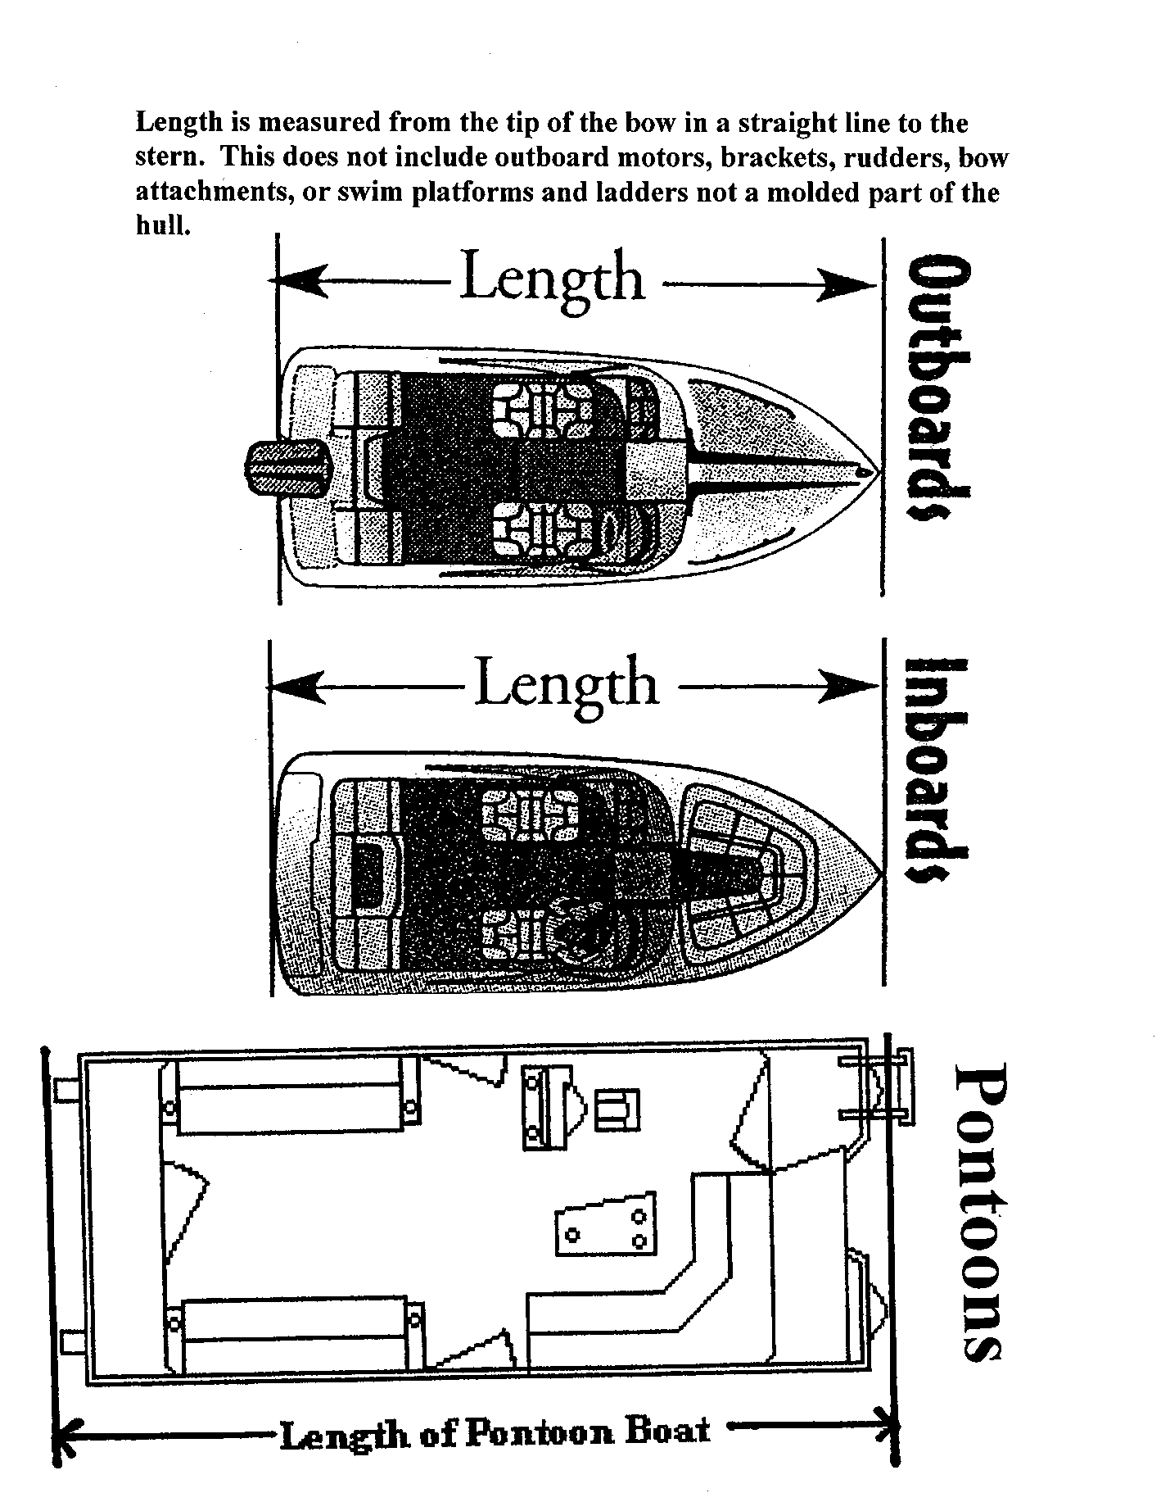

APPENDIX C

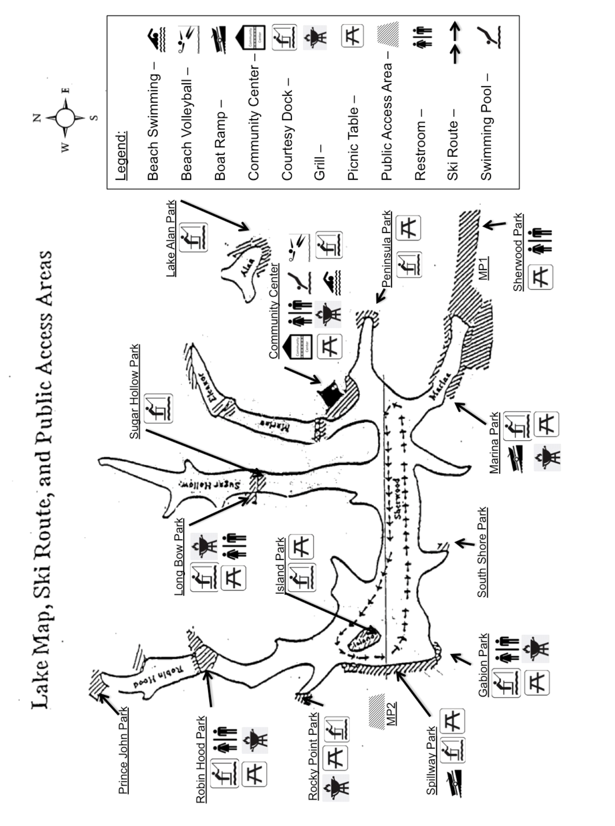

APPENDIX D
Lake Sherwood Registration Decal Placement

Only the current year’s registration decals may be displayed on any WATERCRAFT or trailer. LSEA reserves the right to remove any outdated decals and is not responsible for any damage caused in the process.

Every WATERCRAFT and trailer within the Lake Sherwood Community must display current registration decals.
Registration Decals are issued in sets of two.
WATERCRAFT Registration Decal Placement:
One is to be placed on the STARBOARD (right) and the other on the PORT (left) side of the STERN (back) of the WATERCRAFT. DO NOT PLACE DECALS ON THE BOW (FRONT) OF THE BOAT. Decals must be visible at all times even when the WATERCRAFT is covered. Exception: Registration Decals will be placed within 12" of the front or the back of kayaks, paddle boards and similar WATERCRAFT in such a fashion to they can be seen when the WATERCRAFT is in the water.

Trailer Registration Decal Placement:
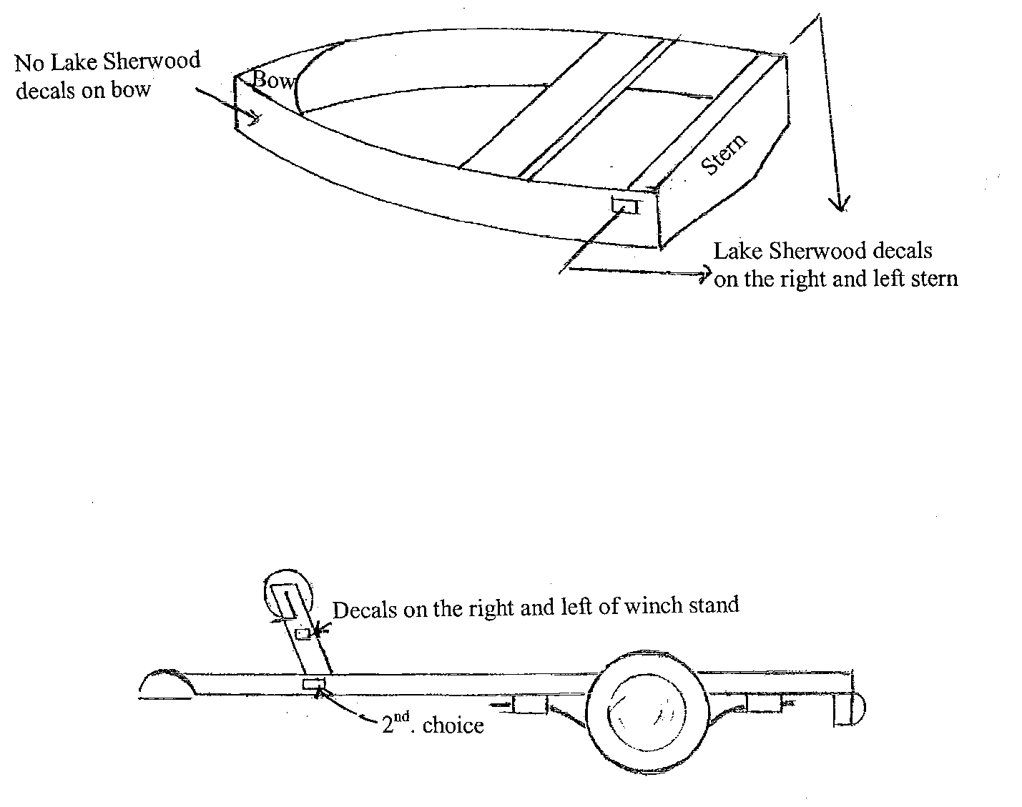
One is to be placed on the right and the other on the left side of the wench stand. If there is no wench stand, the decals are to be placed on the right and left sides of the tongue.

APPENDIX E
Marina Slip Diagram
